I-ROCK Test Data Summary Report

Category: Phyiscal Property Testing

Test Preformed: Compression and Flexural Properties

Test Results See Graph Below:

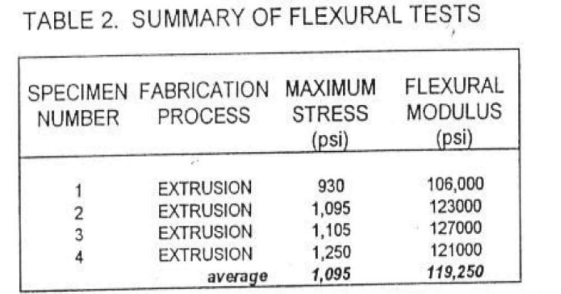

Test Preformed By: Sandia National Labratories

